Learning Metrics Task Force
Phase III Consultation Period
Discussion Guide for Implementation

Background
The Education for All (EFA) goals initiated in 1990 in Jomtien, Thailand demonstrated a commitment to meeting basic learning needs. This commitment was restated in 2000 in the Dakar Framework for Action, in which Goal 6 states; “Improving every aspect of the quality of education, and ensuring their excellence so that recognized and measurable learning outcomes are achieved by all, especially in literacy, numeracy and essential life skills.” Despite this global commitment, at least 250 million primary school age children around the world are not able to read, write or count well according to the 2013 EFA Global Monitoring report, including those who have spent at least four years in school.
In response to this need for improving learning outcomes globally, UNESCO through its Institute for Statistics (UIS) and the Center for Universal Education (CUE) at the Brookings Institution co-convened the Learning Metrics Task Force. Based on recommendations of technical working groups and input from broad global consultations, the task force aims to make recommendations to help countries and international organizations measure and improve learning outcomes for children and youth worldwide.
Phase I of the project sought to identify the learning end-goal by answering the question, what do all children and youth need to learn in order to succeed in the 21st century? Considering recommendations from a working group of experts, the task force decided in its first in-person meeting in September 2012 that indeed there are important competencies that all children and youth should master no matter where they live in the world. The first report from the task force, Toward Universal Learning: What Every Child Should Learn, presents a broad, holistic framework of seven learning domains, with various competencies in each, as the aspiration for all children and youth across the globe. The seven domains are:
- Physical well-being
- Social and emotional
- Culture and the arts
- Literacy and communication
- Learning approaches and cognition
- Numeracy and mathematics
- Science and technology

After identifying these domains of learning, Phase II of the project asked: how will we know whether learning is occurring under each of the seven domains? More specifically, how can we measure and track progress in learning at the global and national levels? Feedback from more than 1,000 teachers, administrators, governments, civil society, donors, and other global education actors in 84 countries has informed task force recommendations. The overwhelming message is that there is a need for (i) building national-level capacity for measuring learning, and (ii) tracking a small set of indicators at the global level.
In the final phase of the project, the task force will answer the question, how can learning measurement be implemented to improve education quality and subsequently learning outcomes? In order to answer this question, the task force and other stakeholders will conduct consultations from 30 April – 15 June 2013 to gain information on how and what learning is being measured, how countries use assessment results, and what barriers exist to the measurement of learning outcomes.
Instructions: Please complete the following discussion guide for the country in which you work. If you work in multiple countries, please complete a separate discussion guide for each country. This guide is divided into three sections:
- Country Capacity for Measuring Learning
- Tracking Global Progress in Learning
- Feasibility of a Multi-Stakeholder Advisory Group on Learning
If your time is limited, you may choose to focus on just one or two of the sections. If you are not sure of the answer to a particular question, or it has been answered in a previous section, simply leave the response area blank.

[Guide continues on the next page]
Discussion Guide
Name and title of facilitator:
Country:

- Country Capacity for Measuring Learning

  - Overall, how is learning measured in [country]? For example:
- Do national policies exist for the measurement of learning?
- Does the country’s strategic plan for education prioritize assessment of learning? If yes, in which areas?
- What are the main types of assessments (local, national, regional, international) that are implemented?
- How do teachers assess student learning against the curriculum?
- Does the country have a department, commission, council, etc. focused on measurement and evaluation in education? Who makes decisions regarding measurement of learning in the country? How do these decisions get made?
  - Does [country] currently measure learning in the seven domains identified in Phase I of the LMTF project (see below and Annex A)?
At what levels (pre-primary, primary, lower-secondary)? Please describe the learning measurement efforts you know of in the following domains. Please include any national, regional, or international assessments.
    - Physical well-being
    - Social and emotional
    - Culture and the arts
    - Literacy and communication—please indicate which language(s)
    - Learning approaches and cognition
    - Numeracy and mathematics
    - Science and technology
To help you elaborate your answer, you may want to think about these measurements in operational terms – name of the measure, objective, frequency of measurement, whether it is conducted country-wide or in individual schools or districts, etc.

  - In the domains where there is no systematic standardized measurement, why is this the case?
Here are a few examples. Please elaborate on these examples if relevant. Can you think of any other possible reasons?
  - The domain is not part of the curriculum
  - Lack of resources
  - Lack of political will to assess learning in this domain
  - Social or cultural constraints to assessing this domain
  - Lack of capacities and technical skills to assess learning in this domain
  - Other

  - What barriers, challenges or obstacles are there to measuring learning in [country]?
(Examples: lack of political will, lack of awareness of the importance of measurement, lack of capacities and technical skills, lack of funding, existing assessments not valid/reliable).
Are there areas of the country where measurement is less developed than others?

  - What future efforts are you aware of for measuring learning in [country]?

  - When [country] collects data on learning, how are the results used?
Here are a few examples of how data on learning can be used. Please elaborate on these examples if relevant.
  - Is the information and data used to inform public policy?
  - Are the results used to modify or adjust curriculum?
  - Are the results used to improve teaching and learning?
  - Are the results used to help teachers and school administrators?
  - Are the results used to track groups of students with the aim of improving/enhancing education?
  - Are the results used to decide which students can progress to the next levels of the education cycle?
Are there any other ways that assessment results have and are being used in [country]?
  - Would a country-level community of practice (CoP) focused on assessment be useful in [country]? A CoP on assessment would be made up of teachers, education ministry officials, local government, civil society, academia, private sector, and others (which may include students in the higher grades, as well as representatives of opposition parties – not in government) to examine and set an agenda for improving assessment practices.
- Does [country] already have a committee, council, or center that fulfills this purpose? Are there multiple bodies that fulfill this purpose? Please describe.
- Who should be involved in a national community of practice on learning assessment? Which organizations, institutions, centers, universities or other entities in [country] do you think should be involved?
- What resources would [country] need to create or sustain a learning assessment CoP?
- What are the best modes of participation in a community of practice in [country]? (Email exchange, virtual platform, conference calls, in-person meetings, etc.)
- How could a country community of practice be supported by international education actors (donors, testing organizations, research institutions, etc.)?

[Guide continues on the next page]
II. Tracking Global Progress in Learning
Through a global consultative process, the Learning Metrics Task Force has proposed six areas for global tracking of learning. These areas are meant to complement efforts to measure a wider set of domains at the national level, as described above. Please note the following definitions according to the International Standard Classification of Education (ISCED):
- Pre-primary (ISCED 0): Commonly referred to as preschool or early childhood education and typically targeted at children aged 3 years until the age to start primary school.
- Primary (ISCED 1): Commonly referred to as primary education, elementary education or basic education. The customary or legal age of entry is usually not below 5 years old nor above 7 years old. This level typically lasts six years, although its duration can range between four and seven years.
- Lower Secondary (ISCED 2): Commonly referred to as secondary school, junior secondary school, middle school, or junior high school. Lower secondary typically begins after four to seven years of primary education, with six years of primary being the most common duration. Students enter lower secondary typically between ages 10 and 13 (age 12 being the most common).

- Does [country] track the following areas of learning? These areas may be tracked by government or non-governmental organizations. If not, please specify why not.
Area of Learning | Yes  Please describe the assessments where applicable. | No  Please describe possible reasons for why not.
Enrollment in preprimary programs
Completion of preprimary programs
Enrollment in primary
Completion of primary
Enrollment in lower secondary
Completion of lower secondary
School readiness/ready to learn upon entry to primary school
Early grade or foundational reading
End of primary reading comprehension
lower secondary reading comprehension
Mathematics and numeracy in primary
Mathematics and numeracy in lower secondary
Skills that meet the demands of the 21st century (e.g., higher-order thinking, collaborative problem-solving, environmental awareness, ICT digital literacy).
The quality of learning opportunities children are exposed to
The content or domains of learning children are exposed to

- What resources currently exist, and what additional resources would [country] need to improve measurement of learning?
- What resources could additionally be provided by the Ministry of Education or other government entities?
- By non-governmental actors in the country (academia, civil society)?
- By a regional organization (if applicable)?
- By international education actors (e.g., donors, private companies, research institutions)?

[Guide continues on the next page]

III. Feasibility of a Multi-Stakeholder Advisory Group on Learning
The Learning Metrics Task Force has proposed a global, multi-stakeholder advisory group to support countries in measuring learning and using assessment to improve quality and learning outcomes. Please read the “prototype” terms of reference (TOR) for this group below and respond to the questions.
Multi-Stakeholder Advisory Group on Learning
Prototype Terms of Reference

The Problem
The latest estimates by the Education For All (EFA) Global Monitoring Report (GMR) point out that 250 million children worldwide are unable to read, write, or count well, including those who have spent four years in school. Yet due to a severe lack of data, primarily in developing countries, we have very little evidence to understand and address learning gaps. For example, while national, regional and global efforts to measure learning have concentrated on literacy and numeracy in primary school, there is widespread agreement that a broader range of skills and further education are essential for children and youth to thrive in a globalized world. In order to better identify specific challenges and develop appropriate policies to improve learning, countries must have comprehensive and accurate information on learning levels, and effective tools to assess learning.

Purpose and Functions
Countries and international organizations are addressing pieces of this overall problem. What is needed now is a means to bring these efforts together and work collectively to improve learning. This is the overarching objective of the proposed Multi-stakeholder Advisory Group.

The following are possible functions and characteristics for a Multi-stakeholder Advisory Group:
- Convening Partners: Convene key actors including teachers organizations, global and regional organizations, assessment experts, private corporations, etc. to provide technical expertise and financial support to countries for measuring learning.
- “Center of Excellence”: House or support a global clearinghouse for best practice and research; be a repository for lessons learned and good practice.
- Policy and Advocacy: Mobilize governments and the international community to devote resources to measuring and equitably improving learning outcomes.
- Global Learning Metrics: Coordinate the development of common metrics for learning indicators and promote their use.
- Standards and Technical Criteria: Set standards for the design and administration of learning assessments; promoting and supporting quality standards for international, regional, and national assessments.
- Contribute to Tracking Progress: Work with existing agencies (UIS, GMR) as they work to compile and report out on global education data
- Capacity Building: Support Communities of Practice (CoPs) at the national level to build capacity and develop actionable plans for measuring and improving learning; support regional education assessment organizations (e.g., SACMEC, PASEC, LLECE).
- Participatory Process: Facilitate a participatory process so that all interested actors have a voice in determining and implementing global metrics
- Official Mandate: Have a recognized mandate among stakeholders

Theory of Change
The Multi-stakeholder Advisory Group will be guided by a theory of change such as the one depicted below. Driven by the need to improve learning outcomes, the priorities for measurement of learning are set at the country level by a CoP comprised of a wide representation of stakeholders in education, such as the education ministry, teachers, school administrators, private sector, parents, civil society, academia, etc. The CoP may or may not choose to use the support provided by the advisory group in determining these priorities. Next, the country would receive technical and financial support from global and regional actors to implement assessments of learning. The data collected would be used to inform policy, and the advisory group can facilitate information sharing and collaboration across countries and regions. The ultimate goal is that education quality and learning outcomes are improved through better measurement, policy, and practices. The main areas supported by the Advisory Group would be 2, 3, and 4 in the figure below.

Multi-stakeholder Advisory Group: Proposed Theory of Change

Mapping Current Efforts
Some components of this international body already exist or are planned. This body would not seek to duplicate these efforts but rather link them together. Regional educational organizations and regional offices of UN agencies, for example, are already fulfilling some of these roles. The following list is a preliminary mapping of global and regional activities to build upon. The Implementation Working Group will conduct a more thorough mapping of these activities to present to the task force. In addition, country-level activities are being gathered during the consultation period and will be incorporated into the next report.

Organization | Activities
Global Partnership for Education | Working with UIS, UNESCO, IEA, regional assessments and other agencies to promote exchanges of information on learning outcomes
UIS/GMR | Global education data gathering and reporting
World Bank | Providing technical assistance to countries for improving assessments systems through SABER and READ
UIS Observatory of Learning Outcomes | Gathering information on all learning assessments at the country level (including national assessments and examinations)
IIEP Portal | Gathering information to guide education ministries on collecting and using learning assessment data
International Association for the Evaluation of Educational Achievement (IEA) | Learning assessment studies in reading (PIRLS and PrePIRLS), mathematics and science (TIMSS), civics and citizenship (ICCS), and an upcoming assessment on computers and information literacy (ICILS). Plans for TIMSS-Numeracy, a less-difficult version of TIMSS, are underway for administration in 2016.
OECD | Learning assessment studies in reading, mathematics, and science (PISA) in addition to financial literacy and collaborative problem-solving. Assessments include contextual questionnaires related to learning environments and non-cognitive outcomes. A PISA for Development initiative is being implemented using expanded instruments in a modified, collaborative framework. PISA assessments are competency-, skills- and content-based.
Regional assessment consortia (PASEC, SACMEQ, LLECE) | Develop and administer regionally-comparable assessments based on national curricula.
Organisation of Eastern Caribbean States | Convened country stakeholders to develop education sector strategy, “Every Learner Succeeds,” which includes agreed-upon learning outcomes for early childhood, primary, and lower secondary
Southeast Asia and Pacific Region (SEAMEO, UNESCO, UNICEF and partners) | Early childhood: UNICEF EAPRO, UNESCO, the Asia-Pacific Regional Network for Early Childhood (ARNEC) and the University of Hong Kong have developed the East Asia & Pacific Early Child Development Scales for children 3-5 which are currently in the validation phase. Primary: there is an initiative underway between UNICEF and SEAMEO to develop metrics for the primary level for SEAMEO member countries, in which UNESCO may engage as well.  Additionally, UNESCO is now working to set up a regional network for the monitoring of educational quality in the region which will focus on information exchange, research and potentially capacity building around assessment issues.

- Could a multi-stakeholder global advisory group help [country] improve learning measurement?
  - Do you currently have any advisory group supporting you from an international level?
  - How could such a group be helpful to [country]? What role would the advisory group have?
  - What challenges do you see to governments accessing the type of assistance and resources this group could offer?
  - What concerns do you have about such a group? What are some of the risks associated with the convening of this advisory group?
  - What types of representatives should form part of the group?

- What other efforts are you aware of at the regional or global level that are supporting countries in measuring and improving learning?

- Finally, do you have any other ideas on how [country or government] could be supported in making sure children are in school and learning?

[Discussion guide ends here]

Thank you kindly for your time and feedback.
Please email participant responses by 15 June 2013 to learningmetrics@brookings.edu to ensure they inform the working group’s recommendations to the task force.

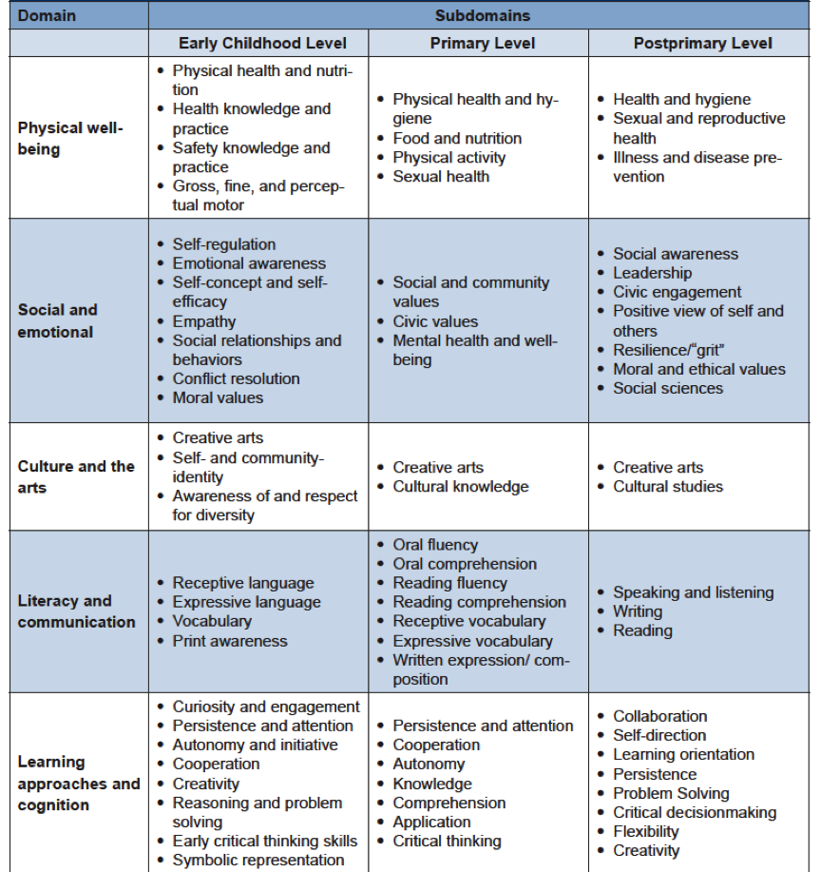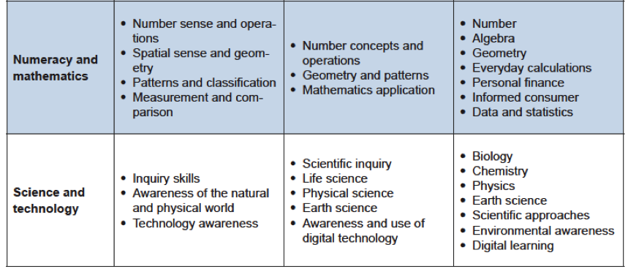Annex A. Seven Domains of Learning Framework

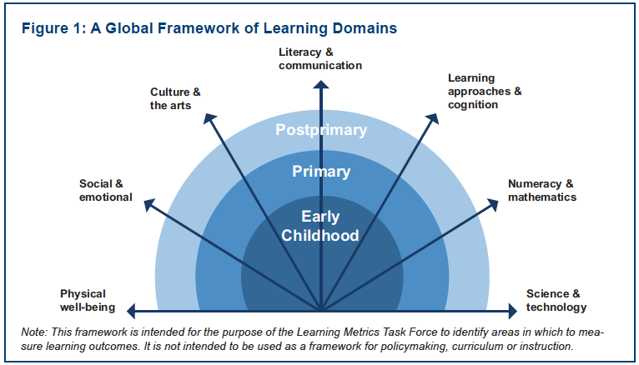

Systematic standardized measurement refers to any effort in which the same assessment is given in the same manner to all learners.
UNESCO Institute for Statistics. (2011). International Standard Classification of Education (ISCED) 2011. Available from: http://www.uis.unesco.org/Education/Documents/isced-2011-en.pdf
A prototype is an early draft meant to test a concept or idea.

